# Corridor size

Corridor 1 (short): **W = 1.44m**, **L = 8.2m**

Corridor 2 (long): **W = 2.78m**, **L = 13.5m**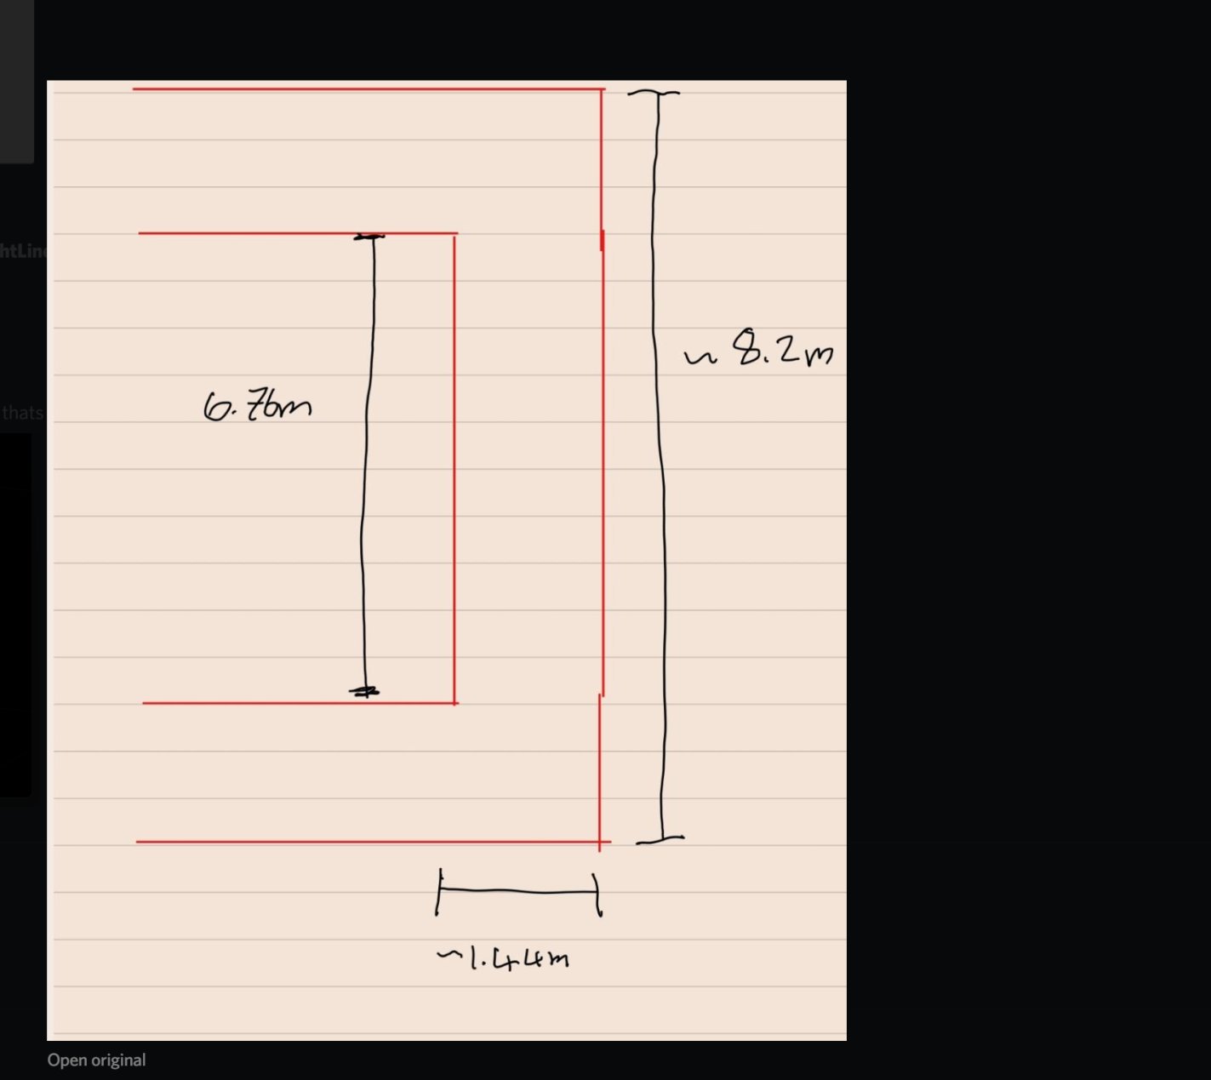

IE Room: 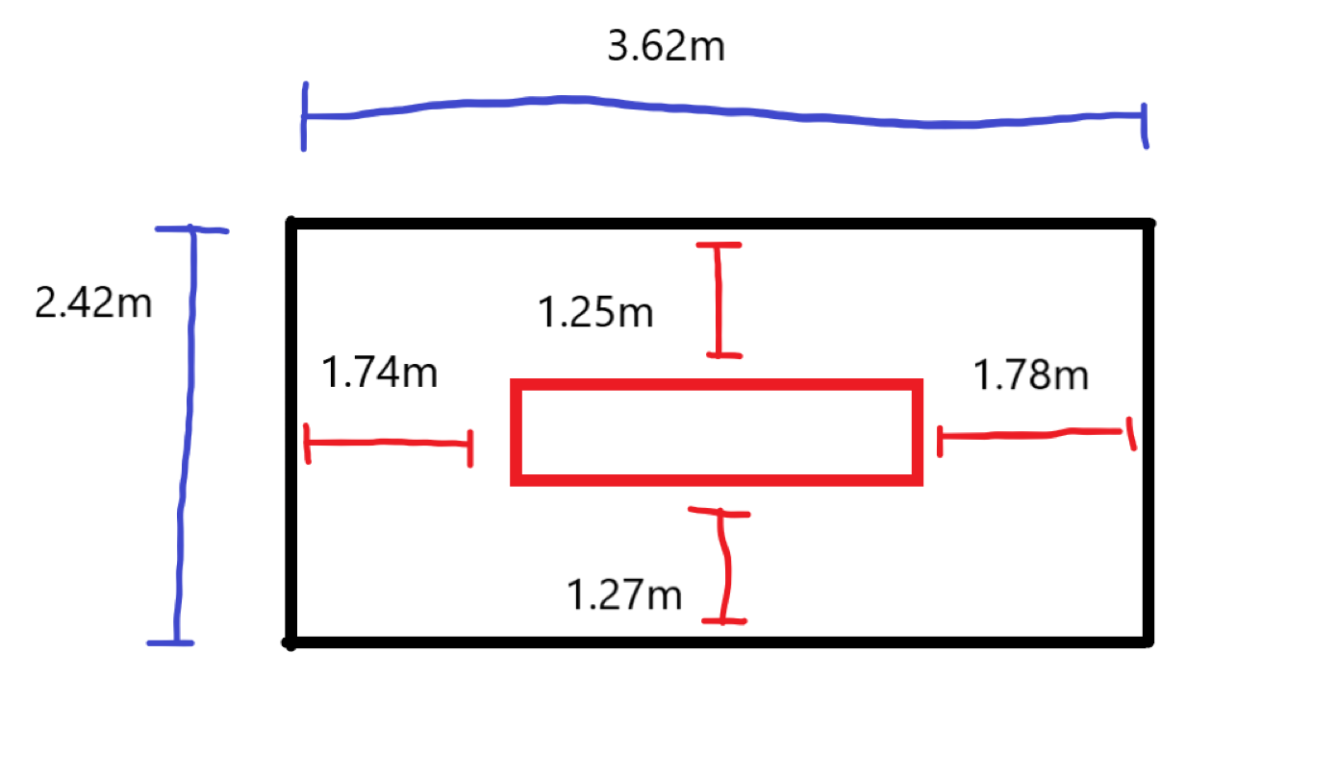

# Point cloud

# 

# ICP

## Corridor 1 measurements

| Motion | Frames merged | Data visualisation | Length accuracy |
| --- | --- | --- | --- |
| Straight line | 5 |  | 4.78m vs 6.76m  **70.71%** |
| Straight line | 10 |  | 6.76m vs 6.76m  **100%** |
| Straight line | 15 |  | 4.98m vs 6.76m  **73.67%** |
| L-Shape | 5 |  | TBC |
| L-Shape | 10 |  | TBC |
| L-Shape | 15 |  | TBC |
| U-Shape | 5 |  | TBC |
| U-Shape | 10 |  | TBC |
| U-Shape | 15 |  | TBC |

Notes:

* Speed of rotation was slow and done on the spot
* Full loop not considered due to poor performance with U-Shape
* Height of sensor centred in the middle of the corridor: ~1m (need to verify)

## Corridor 2 measurements

| Motion | Frames merged | Data visualisation | Length accuracy |
| --- | --- | --- | --- |
| Straight line | 5 |  | 5.03m vs 13.5m  **37.26%** |
| Straight line | 10 |  | 6.29m vs 13.5m  **46.60%** |
| Straight line | 15 |  | 3.45m vs 13.5m  **25.56%** |

## IE Room measurements

| Motion | Frames merged | Data visualisation | Length accuracy |
| --- | --- | --- | --- |
| Straight line | 5 |  | 3.62m vs 4.03m  **113.33%** |
| Straight line | 10 |  | 3.62m vs 3.28m  **90.61%** |
| Straight line | 15 |  | 3.62m vs 1.81m  **50.00%** |
| LShape | 5 |  |  |
| LShape | 10 |  |  |
| LShape | 15 |  |  |
| UShape | 5 |  |  |
| UShape | 10 |  |  |
| UShape | 15 |  |  |

# ICP Objective Function